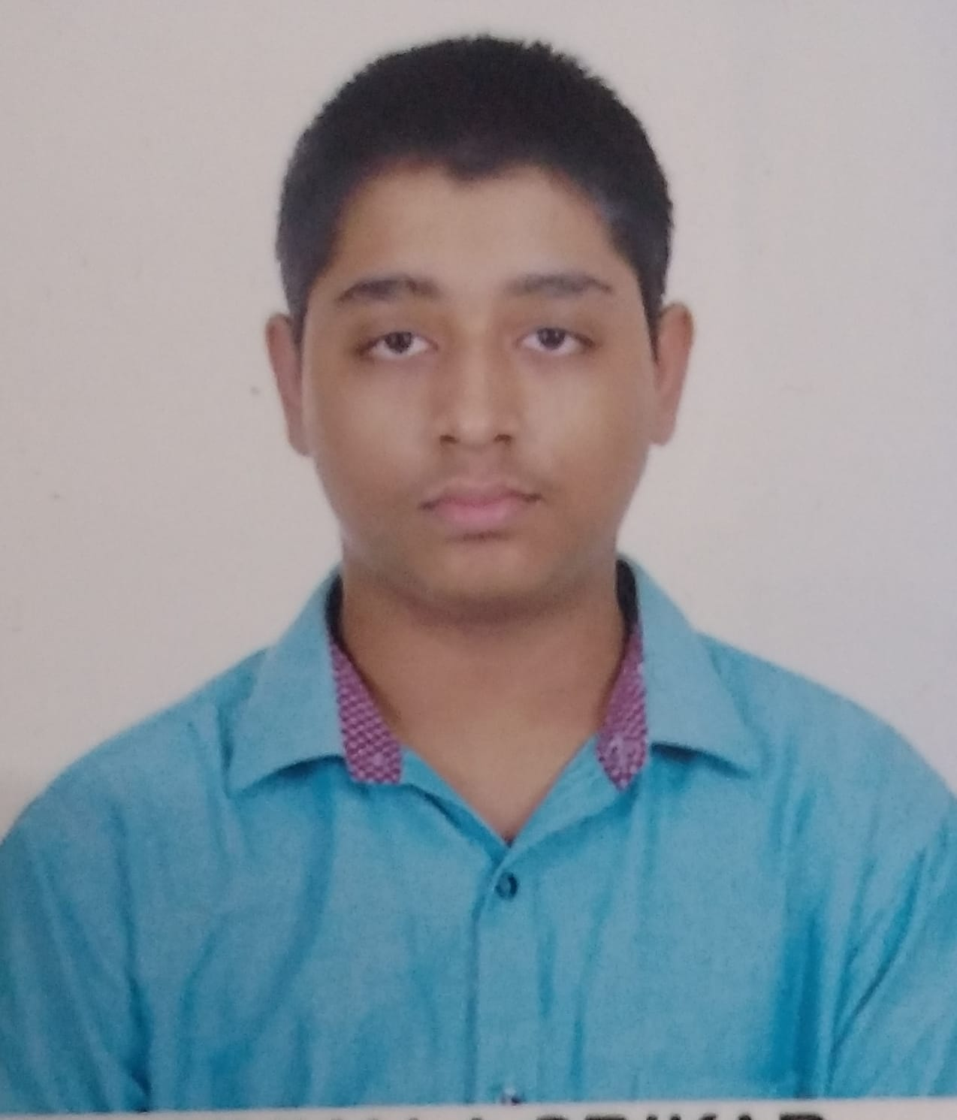
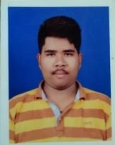
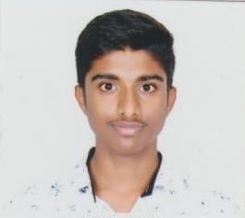


Team Name:
Team 57

Team
Department:Computer Science Engineering

Name: Nukala Srikar
RollNo:19131A05G1
Mail: 19131a05g1 @gvpce.ac.in
Mobile:9491673788

Name: Pokala Divya Gandh
RollNo:1913A05H7
Mail: 19131a05h7 @gvpce.ac.in
Mobile:7995376867
Name: Nitin Ancha
RollNo:19131A05G0
Mail: 19131a05g0@gvpce.ac.in
Mobile:9346625657
Project Guide
Name: P Sravya
Mail: sravyapallantla@gvpce.ac.in
Mobile:9849815160

Abstract
We all know that to run a business customers are important. The business people believe that “customers should be treated as Gods”. To maintain relationship between customer and owner and their trust is more important to run a business for long term. Here we get a solution for that, using our Customer Segmentation that company could know about the customer and produce products, give special offers and act according to customer needs, so there would be a great relationship between customer and owner. We used Machine Learning in R, we visualize and analyse the data based on age, gender, income and spending score. We also use clustering Techniques. We try increase the clusters of customers for more analysis.
Domains where our solution can be implemented
- Companies
- Business
- Dealers, etc;

Our solution helping the selected domain
The companies, businesses, dealers etc, who are selling or sells products get benefit of our project.
Our engineering solution
Using Machine Learning Customer Segmentation to know about customers analysis on products, based on age, income, gender and spending score.
Team’s vision
Our main vision is to segment customers and make easy to companies to release products and offers according to that data.

